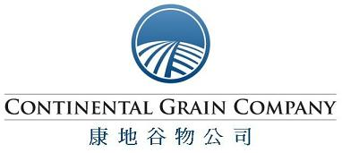

ContiAsia Headquarters
705 Union Plaza, 20 Chaowai Avenue, Chao Yang District, Beijing
北京市朝阳区朝阳门外大街20号联合大厦705室
Tel: +86 10 65883388
Fax: +86 10 65880086

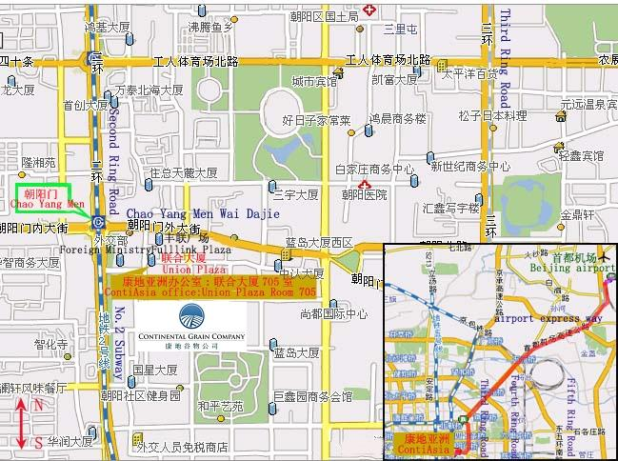
☆ContiAsia office is on the southeast of Chao Yang Men bridge on the Second Ring Road. It is on the south of Fulllink Plaza and on the east of Foreign Ministry.
康地亚洲办公室在二环朝阳门桥的东南边，丰联广场南边，外交部东边。
☆10 minutes walk from Chao Yang Men station of No.2 subway.
从地铁二号线的朝阳门站下车需步行十分钟。
☆One hour by car from Beijing airport.
从首都机场乘车需一小时。

